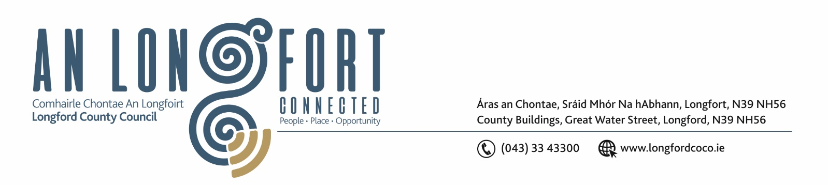

8u Feabhra 2018.

Chuig: Gach Ball don Chomhairle.

A Chomhairleoir,

Iarrtar ort bheith i láthair ag Cruinniú Míosuil Chomhairle Chontae Longfoirt a tionólfar i Seomra na Comhairle, Aras an Chontae, Longford ar an Chéadaoin, 14u Feabhra 2018 ag 4.00 p.m chun gnó a dhéanamh d’réir an Chláir thíos.

You are requested to attend the Monthly Meeting of Longford County Council to be held in the Council Chamber, Aras an Chontae, Great Water Street, Longford on Wednesday, 14th February 2018 at 4.00 p.m. to transact business, as set out on the Agenda hereunder.

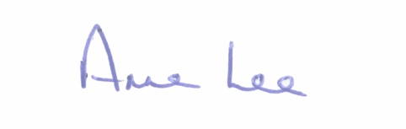
Mise le meas,

__________________
Anne Lee,
Meetings Administrator.

Note.

County Longford Diaspora launch will be held at 3.30 p.m. in the Council Chamber.

C L A R

- Confirmation of Minutes of Monthly Meeting of Longford County Council held on the
10th January 2018 – copy enclosed.

- Matters arising from Minutes.

- To note Chief Executive Orders - enclosed.

4 . To note Monthly Management Report - to follow.

5. To note adopted Minutes of Corporate Policy Group Meeting held on
13th December 2017 - enclosed.

6. Economic and Community Development, Planning, Human Resources & Corporate Services, Cultural & Recreational Services.

- To note Planning Applications received since December meeting of the Council.

- Review of Local Electoral Areas – Invitation for Submissions.
Correspondence circulated on the 23rd January 2018 –copy enclosed.

- Consideration of appointment of Ms. Emma Kiernan, nominee of Longford Public Participation Network, as a representative on behalf of the youth sector to replace
Aisling Nolan as a member of Longford Joint Policing Committee (JPC).

- Consideration of appointment of one member to the Board of Longford Community Resources clg. (to replace Councillor Mick Cahill who resigned on the 12th December 2017)
- correspondence enclosed.

- Report on independent Legal Advice regarding Wind Turbines - enclosed.

- Set date for March meeting of the Council.

7. Finance & Information Systems.

- To note Public Liability Claims received during January 2018.

- Local Government Act 2001 - Annual Ethics Declaration.

- Presentation on the Mobile Phone Voice Black Spot Identification Survey.

- To note NOAC 2016 Performance Indicators Report - attached.

- Notice of Motion received from Councillor Michael Carrigy -

“Could I get an update on my motion for a 10% rates refund for businesses in our county whose annual payment is under €10,000.”

8. General.

- Correspondence – enclosed.

- Letter dated 18th January 2018 received from the Office of the Minister for Housing regarding Income Thresholds for Housing Supports.

9. Training –

Consideration of Report from Corporate Policy Group.

10. Votes of sympathy.

